**Programing language R (object oriented language)**

**Introduction to R programming language : (Sheet: 01)**

***Assignment no: 1***

Mathematical operation:

|  |  |
| --- | --- |
| Question | Answer |
| pi  x<-2;y<-3;x^y;  sqrt(x)  abs(x)  factorial(x)  log(x,base=2)  log10(x)  log2(x)  exp(2)  cos(x)  sin(x)  tan(x);  x<-1;  acos(x)  asin(x)  atan(x)  2*pi/3-sqrt(4)  abs(12-17*2/3-9)  exp(log(2))  10^log10(2)  asin(1/sqrt(2))*180/pi | > pi=[1] 3.141593  > x<-2; > y<-3; > x^y;=[1] 8  > sqrt(x)=[1] 1.414214  > abs(x)=[1] 2  > factorial(x)=[1] 2  > log(x,base=2)=[1] 1  > log10(x)=[1] 0.30103  > log2(x)=[1] 1  > exp(2)=[1] 7.389056  > cos(x)=[1] -0.4161468  > sin(x)=[1] 0.9092974  > tan(x)=[1] -2.18504  > x<-1;  > acos(x) = [1] 0  > asin(x)=[1] 1.570796  > atan(x)=[1] 0.7853982  > 2*pi/3-sqrt(4) =[1] 0.0943951  > abs(12-17*2/3-9) = [1] 8.333333  >exp(log(2))=2  10^log10(2)= 2  asin(1/sqrt(2))*180/pi= 45 |

**(1)Creating vector:**

|  |  |
| --- | --- |
| Question | Answer |
| a.(1,2,3……..19,20) | > x<-c(1:20); > x;=[1] 1 2 3 4 5 6 7 8 9 10 11 12 13 14 15 16 17 18 19 20 |
| b.(20,19……..2,1) | rev(x)=[1] 20 19 18 17 16 15 14 13 12 11 10 9 8 7 6 5 4 3 2 1  or  > x<-c(20:1)  > x=[1] 20 19 18 17 16 15 14 13 12 11 10 9 8 7 6 5 4 3 2 1 |
| c.(1,2…….19,20,20,19……2,1) | x<-c(1:20,20:1);  >x; =[1] 1 2 3 4 5 6 7 8 9 10 11 12 13 14 15 16 17 18 19 20 20 19 18 17 16  [26] 15 14 13 12 11 10 9 8 7 6 5 4 3 2 1 |
| d. (4,6,3) and assign it to data…… | > x<- c(4,6,3);x;=[1] 4 6 3 |
| e. (4,6,3,4,6,3, , , , , , 4,6,3) where there are 10 occurance of 4,6,3…. | > data<- c(4,6,3);data;=[1] 4 6 3  > rep(data,10)=[1] 4 6 3 4 6 3 4 6 3 4 6 3 4 6 3 4 6 3 4 6 3 4 6 3 4 6 3 4 6 3 |
| f. (4,6,3,4,6,3,,,,,,,,,,,,,,,4,6,3,4) where there are 11 occurance of 4, 10 occurance of 6 and 10 occurance of 3.. | > data<-c (4, 6, 3)  > rep (data,l=31)=[1] 4 6 3 4 6 3 4 6 3 4 6 3 4 6 3 4 6 3 4 6 3 4 6 3 4 6 3 4 6 3 4 |
| g. (4,4,4,,,,,,,,,,6,6,6,,,,,,,,,,,,3,3,3,3) where there are 10 occurance of 4, 20 occurance of 6 and 30 occurance of 3…… | z<-rep(data,times=c(10,20,30));z;  =[1] 4 4 4 4 4 4 4 4 4 4 6 6 6 6 6 6 6 6 6 6 6 6 6 6 6 6 6 6 6 6 3 3 3 3 3 3 3 3  [39] 3 3 3 3 3 3 3 3 3 3 3 3 3 3 3 3 3 3 3 3 3 3 |
| h. Create a vector of the values of $e^{x}\cos{(x)}$ at x= (3,3.1,3.2,……,5.9,6) | >x<- seq(3,6 by=0.1);  >y<- exp(x)*cos(x);  >z<- data.frame(x,y);z; |

**Question no 2: Create the following vector:**

|  |  |
| --- | --- |
| Question | Answer |
| 1. (a)(0*.*130*.*21*,*0*.*160*.*24*,...,*0*.*1360*.*234) |  |
|  |  |

**Question no 3: Create the following vector:**

|  |  |
| --- | --- |
| Question | Answer |
| $\sum_{i=10}^{100}{(i^{3}+{4i}^{2})}$ |  |
|  |  |

**Question no 4: Create the following vector:**

|  |  |
| --- | --- |
| Question | Answer |
| 1. Create a vector from 0 to 1 in increments of 0.1 |  |
| 1. Print out the first 3 element of m and only third element, replace the third element. |  |
| 1. Create a vector consisting of 3 names |  |
| 1. Create vector x,y and include in matrix |  |

**Assignment no:2**

**Question** : Trees data set provides the measurement of the girth height and volume of timber in 31 felled black cherry trees. Give the answer of following question.

|  |  |
| --- | --- |
| Question | Answer |
| 1. Read the trees data set. |  |
| 1. Just read the variable name girth. |  |
| 1. Attached trees data set |  |
| 4) Remove tress data set from work space |  |
| 5)  Simple histogram of volume |  |
| 6) Box plot of girth | **Comment:** There is no outlier in girth variable. |
| 1. Scatter plot of girth and height |  |
| 8)Make five number summary of girth variable |  |
| 9)Find variance and length ,standard deviation of girth variable |  |
| 10)Calculate correlation coefficient. |  |

**Introduction to MATRICES: (Sheet: 02)**

**Assignment no :03 (sheet-2)**

|  |  |
| --- | --- |
| Question | Answer |
| A= $\begin{matrix}1 & 1 & 3 \\ 5 & 2 & 6 \\ -2 & -1 & -3\end{matrix}$ | > A<-matrix(c(1,5,-2,1,2,-1,3,6,-3),3,3); > A;=  [,1] [,2] [,3]  [1,] 1 1 3  [2,] 5 2 6  [3,] -2 -1 -3 |
| a .Check that A^3=0; | > result<-A%*%A%*%A;  result; =  [,1] [,2] [,3]  [1,] 0 0 0  [2,] 0 0 0  [3,] 0 0 0 |
| b .Replace the third column of A by the sum of the second and third columns. |  |
| c. replace the 2nd row of A by the subtraction of 2nd and third of A. |  |
| ##create the following matrix B with 15 row. |  |
| ## calculate the 3*3 matrix $B^{/}B$ |  |
| ## show system date |  |

**Question : 01**

**A relationship between a childs height and their head circumstance …….**

|  |  |  |  |  |  |  |  |  |  |  |  |
| --- | --- | --- | --- | --- | --- | --- | --- | --- | --- | --- | --- |
| Height | 27.75 | 24.5 | 25.5 | 26 | 25 | 27.75 | 26.5 | 27 | 26.75 | 26.75 | 27.5 |
| Circum- ference | 17.5 | 17.1 | 17.1 | 17.3 | 16.9 | 17.6 | 17.3 | 17.5 | 17.3 | 17.5 | 17.5 |

***Answer:***

|  |  |
| --- | --- |
| Question | Answer |
| a.Read this data in R | Or,    variable<-data.frame(height,circumference);  attach(variable);variable;  plot(variable$height,variable$circumference); |
| b. make a scatter plot circumference against height. | **Comment:** There appearance to be a positive linear relationship between two variables. |
| c. Find co-variance of height and circumference and comment. |  |
| d. find co-relation between height and circumference. |  |
| e. Fit a simple linear regression of height and circumference. |  |

**Introduction to probability distribution: (Sheet : 03)**

**Assignment no: 04**

**Probability mass function for the binomial distribution.**

|  |  |
| --- | --- |
| Question | Answer |
| suppose that a fair dice is rolled 10 times. What is the probability of throwing exactly two sixes? |  |

**Probability density function for normal distribution :**

|  |  |
| --- | --- |
| Question | Answer |
| Fin the value of the pdf at x=2.5 for a normal distribution with the mean of 5 and a standard deviation of 2. |  |

**Finding probability :**

|  |  |
| --- | --- |
| Question | Answer |
| 1. For the standard normal distribution find the probability that a randomly selected value will be less than or equal to 2.5. |  |
| 1. For normal distribution where mean=5, SD=2, 2. When X=6 3. When x>6 | a.    b. |
| 1. The number of lobster ordered in a restaurant on a given day is known to follow a poisson distribution with a mean of 20. What is the probability that exactly 18 lobsters will be ordered tomorrow ? |  |
| ***Finding quartiles*** |  |
| 1. For a standard normal distribution find the value below which 95% of values fall? |  |
| 1. Suppose a variables known to be normal distributed with a mean of 5 and standard deviation of 2. 2. Find the value below which 95% of the population falls? 3. Value above which 95% of the population falls? | Answer: |
| 1. A manufacturer of special type of one size glove wants to design the glove to fit at least 99% OF THE POPULATION. HAND span is known to be normally distributed with a mean of 195 millimeters and standard deviation of 17 millimeters.   ## *what range of the hand spans must the glove accommodate?* |  |
| **One sample t test** |  |
| *An outbreak of salmonella related illness was attributed to ice-cream produced at a certain factory scientist measured the level of salmonella in 9 ice-cream: (.**593, .142, .329, .691, .231, .793, .519, .392, .418)**    *## is there any evidence that the mean level of salmonella in the ice-cream is greater than 0.3MPN/g?* | Answer:  From output: x’=0.45, t static=2.2, degree of freedom=8, p-value=.029 , here p<level of significance (.05)  So, we may reject null hypothesis.(m1<=.3)  And accept m1>.30 |
| *Six subjects were drug treatment group and additional 6 subjects a place. there reaction time was measured …  ***Control group: (91,87,99,77,88,91)***  ***Treatment group: (101,110,103,93,99,104)*** | mean of x and y is 88.83333 101.66667  t = -3.4456, df = 10, p-value = 0.003136<level of significance (.05)  So, we may reject null hypothesis m1=m2 and accept m1<m2 . |
| A study was performed to test whether cars get better millage an premium gas than regular gas. Each of 10 cars was first filled with regular gas or premium gas decided by a toss and the millage for that tank was recorded again for the same cars using the other kind of gasoline use paired **t test** to determine whether cars get significantly better millage with premium gas.  **Regular gas:**  **(** **16,20,21,22,23,22,27,25,27,28)**  **Premium gas: (19,22,24,24,25,25,26,26,28,32)** | data: b and a  t = 4.4721, df = 9, p-value = 0.0007749<level of significance(.05), So we may reject null(m2=m1)  hypothesis and accept alter (m2>m1) hypothesis. |

**Assignment no:05 (sheet no :4)**

**Construction of matrix:**

|  |  |
| --- | --- |
| Question | Answer |
| **If X=**   1. Find transpose of X. 2. Calculate X’ and find XX’. 3. Find diagonal of X. 4. Find determinant of X 5. Find inverse of X 6. Find dimension of X | a). b)  c)  d) e)  f) |

|  |  |
| --- | --- |
| Construct this:  Y= |  |
| Create a matrix **Y** given below: |  |
| **Form Y :**   1. Create Y1=1st row. 2. Create Y2=2nd row. 3. Create Y3=3rd row. |  |
|  |
|  |

|  |  |
| --- | --- |
| Plot (y2 vs y1) AND (y3 vs Y1) |  |

**Question:**

|  |  |  |  |  |  |  |  |
| --- | --- | --- | --- | --- | --- | --- | --- |
| X1 | 10 | 15 | 20 | 25 | 30 | 35 | 40 |
| Y1 | 32 | 47 | 62 | 77 | 92 | 107 | 122 |
| Y2 | 42 | 62 | 82 | 102 | 122 | 142 | 162 |
| Y3 | 22 | 25 | 28 | 35 | 40 | 45 | 50 |

|  |  |
| --- | --- |
| Question | Answer |
| Plot X1 vs Y1 and X1 vs Y2 and X1 vs Y3 |  |

**Question:**

|  |  |  |  |  |  |  |
| --- | --- | --- | --- | --- | --- | --- |
| X = | 5 | 10 | 15 | 20 | 25 | 30 |

1. Draw a histogram of X.
2. Select randomly 50 observations from the normal distribution. And draw a histogram.

**Answer: (1)**



histogram: 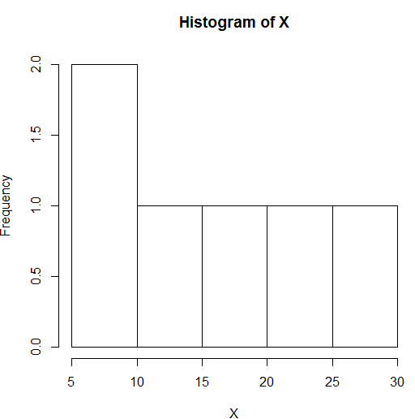

(2)



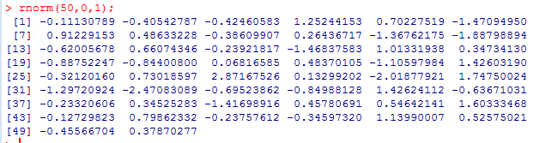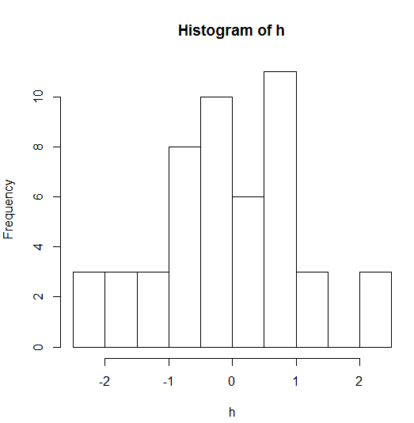

**Sampling distribution:**

|  |  |
| --- | --- |
| **Question:** Draw a random sample of five number from the set of 1:40;  # without replacement.  ## with replacement. |  |
| **Question :** simulate 10 coin tosses .where head (H) and tail(T) have chance . |  |
| **Question:** simulate 90% chance of success and 10% chance of failure of a random experiment. |  |
| **Question :** how many ways you choose give numbers out of 40. |  |

**Probability distribution:**

1. X~binomial (20,0.3)

|  |  |
| --- | --- |
| Question | Answer |
| 1. P(x=3) |  |
| 1. P(x<=3) |  |
| 1. P(3<x<7) |  |
| 1. Draw a random sample (n=100) for binomial (20,0.3) |  |

1. X~poisson (Ύ=7.2)

|  |  |
| --- | --- |
| Question | Answer |
| 1. P(x=3) |  |
| 1. P(x<=2) |  |
| 1. P(X>7) |  |
| 1. P(x>=9) |  |
| 1. P(3<x<9) |  |
| 1. P(3<X<=9) |  |
| 1. P(3<=x<=9) |  |

1. Let x~N(0,1) find P(X>3).

**Answer**: 

2. X follows normal distribution with mean 35 and standard deviation 6.

** find P(X>42)

**Answer:** 

1. X~N(20,4)

|  |  |
| --- | --- |
| 1. Find f(22) |  |
| 1. Find P(16<X<24) |  |
| 1. Find b such that P[X<b]=0.5 |  |
| 1. Draw a random sample of size 30 and create vector. |  |

**Writing my own function :**

|  |  |  |
| --- | --- | --- |
| Question | Answer | |
| 1. F(X)=+2x+3 |  | |
| 1. Write and an R function that will take a vector (x,say) as input and calculate . 2. /n-1   b.  /n-1 | a.    b. | |
| 1. write a R function that will take a vector X and a constant C as argument.  * a.Find $\sum{x^{2}}$* b.If $\sum{x^{2}}$ >C ,return 1 or 0. | | a.    b. |
| 1. Suppose you have a p*q dimensional matrix write a R function that will find the column such as vector. | |  |
| **Some other topic:**  **Legal Operator:**  Suppose U=(1,2,3,4,5,6,7,8,9,10).   1. Calculate sum of U when (u>4). 2. Replace the value of U by 10 when U<4 and calculate the sum of U. 3. Replace U<4 or U>8 by 10 and calculate sum of U. 4. Replace not equal 2 by 6 and calculate sum of U.  |  |  | | --- | --- | | **Solution 1:**  **Code:**  u<-1:10  sum(u[u>4])  **Output: 45** | **Solution 2:**  **Code:**  u<-1:10  u[u<4]=10;u  sum(u)  **Output: 79** | | **Solution 3:**  **Code:**  u<-1:10  u[u<=4 | u>=8]=0;u  sum(u)  **Output: 18** | **Solution 4:**  **Code:**  u<-1:10  u[u!=2]=6;u  sum(u)  **Output: 56** | | | |